OFFICE OF THE SHERIFF
RED RIVER COUNTY, TEXAS

JIMMY CALDWELL, SHERIFF
RED RIVER COUNTY SHERIFF’S OFFICE
500 N CEDAR STREET CLARKSVILLE, TX 75426
903/427-3838
903/427-0830 FAX

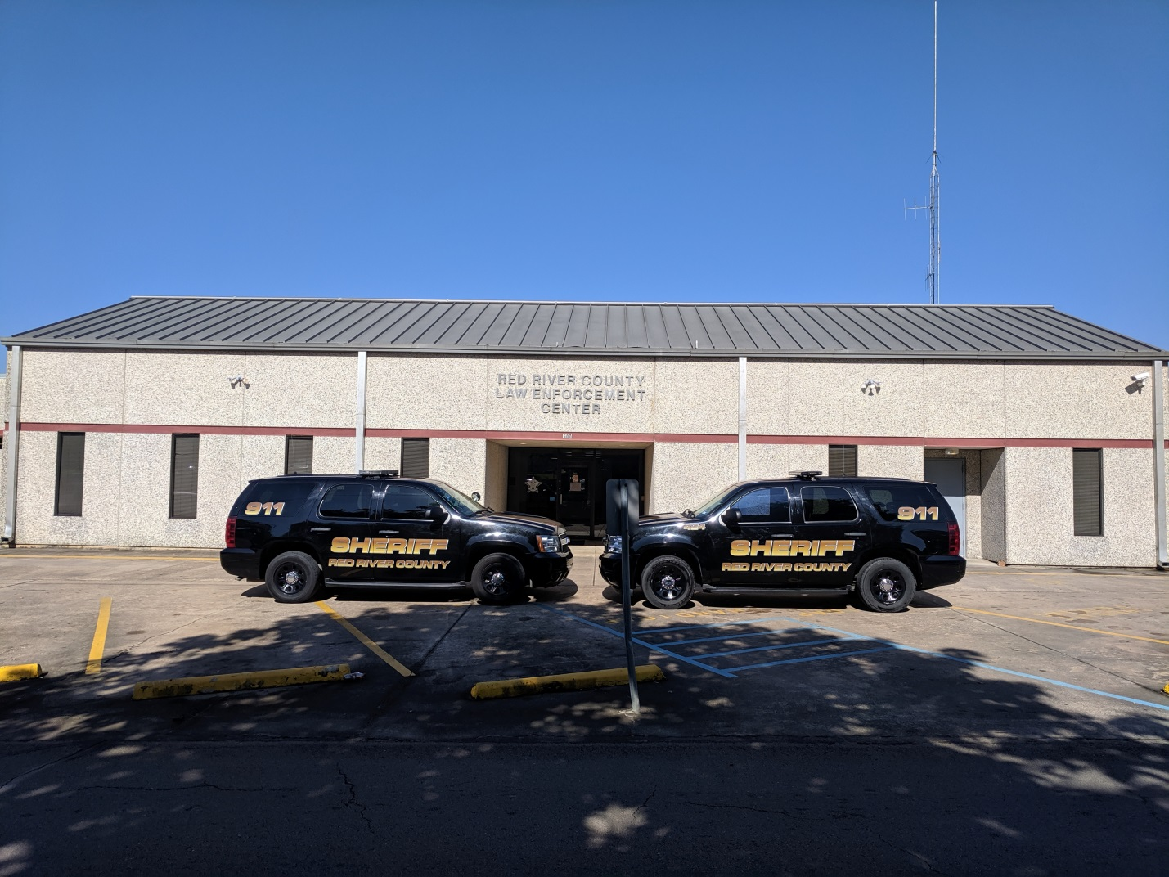

The Red River County Sheriff’s Office is taking Applications for the position of Patrol Deputy.

Minimum Requirements: Must be 21 years of age, have a TCOLE Peace Officer License, and have a valid Texas Driver’s License. Must also pass a drug screening and background check.

Certificate Pay, Excellent Longevity Pay, STEP supplemental pay opportunities, off duty pay opportunities, take home units (out to the county line), Good affordable Health Insurance, Awesome Retirement Plan, and training opportunities for motivated employees.

Great citizens to work for and great Community to work in. Awesome Department Personnel and Sheriff to work with. Applications can be filled out online at the TCOLE Website or come by and pick one up at the office.
Red River County is an Equal Opportunity Employer

